**BIGG BOSS VOTING ZONE**

A MINI PROJECT REPORT

*Submitted by*

Group: **G-24**/Team No: **T-20**

KASHISH GOYAL (2210990496)

KASHISH BARTHWAL (2210990495)

ARUSHI CHAWLA (2210990999)

***in partial fulfilment for the award of the degree***

***of***

**BACHELOR OF ENGINEERING**

in

**COMPUTER SCIENCE & ENGINEERING**



**CHITKARA UNIVERSITY**

**CHANDIGARH-PATIALA NATIONAL HIGHWAY RAJPURA (PATIALA)**

**PUNJAB-140401 (INDIA)**

**MAY,2023**

**ABSTRACT**

This research sheet describes the development and implementation of a word counter tool using CSS, HTML, and JavaScript. The tool is designed to allow users to input text and count the number of words in that text, with a focus on simplicity, user-friendliness, and ease of use. The user interface is created using HTML and CSS, with a clean and simple design that allows users to quickly and easily input text and view the word count. The design is optimized for readability and ease of use, with clear instructions and visual cues to guide the user. The functionality of the word counter is implemented using JavaScript, with a focus on efficiency and accuracy. The JavaScript code uses regular expressions to identify words in the input text, and then counts the number of matches to determine the total word count. The code is designed to handle a wide range of input types and formats, including text with punctuation, special characters, and line breaks. The study involved asking participants to use the tool to count the number of words in a variety of text samples, and then providing feedback on their experience. The results of the study showed that the tool was highly effective at accurately counting words in a range of text formats, and that participants found the tool to be highly user-friendly and intuitive. Overall, this research sheet demonstrates the effectiveness of using CSS, HTML, and JavaScript to create a simple and user-friendly word counter tool. The tool has a wide range of potential applications, including for writers, editors, and students who need to keep track of the number of words in their writing. Future research could focus on enhancing the tool with additional features, such as the ability to count words in specific sections of a text, or to track changes in word count over time. The following table offers a suggested structure and approximate word counts for dissertations, relative to the degree being pursued. This is designed to be altered according to the needs of the researcher, and the stipulations of their supervisor and institution. All dissertations are different, and your supervisor is the best person to talk to about your specific institutional, school, or college requirements, which may vary quite significantly. Creating your own outline through discussion with your supervisor gives you both a sense of where you are in the process and what needs to be done, whilst also functioning as a reference point when completing smaller intermediary targets. The examples below illustrate a general principle of successful research espoused by this book: a larger project becomes much more manageable when broken down into smaller, clearly defined sections.

**TABLE OF CONTENTS**

|  |  |  |
| --- | --- | --- |
| **S. No** | **Section** | **Page No.** |
| 1 | Introduction | 4 |
| 2 | Problem Statement | 5 |
| 3 | Technical Details | 6 |
| 4 | Key Features | 7 |
| 5 | Project Advantages | 8 |
| 6 | Code and its output explanation | 9 - 12 |
| 6 | Bonus Feature | 13 |
| 7 | Conclusion with future scope | 14 |
| 8 | References | 15 |

**Introduction:**

**BIGG BOSS VOTING ZONE**

**OVERVIEW OF THE PROJECT:**

In this project we have created a dynamic voting system that displays live vote count. This is achieved by the use of various programming languages like HTML, CSS and JavaScript. Not only does this offer secure and accurate voting but also offers interactive system for better user experience.

1. Big Boss is a highly popular reality show known for its intense competition among contestants who live together in a controlled environment for a specific duration. The primary objective of the show is to determine the ultimate winner, who is crowned the Big Boss.
2. Security and reliability are key considerations in the design of the voting system. Measures are put in place to safeguard the integrity of the voting process, prevent fraudulent activities, and ensure that each vote is counted accurately. This helps maintain the trust of the audience in the fairness of the competition.
3. The transparency of the voting system helps eliminate doubts or suspicions about the fairness of the competition. It assures both the contestants and the audience that the winner is chosen based on genuine votes and reflects the collective choice of the viewers.
4. The voting system plays a crucial role in the overall success of the Big Boss show. It gives the audience a sense of involvement and empowerment by allowing them to influence the outcome. Additionally, it creates excitement and anticipation as viewers eagerly await the results, fostering a sense of community and shared experience.

**Problem Statement:**

1.) A Voting platform is to be designed to show the increase/decrease in the votes of particular contestant using HTML, CSS and JS

.

2.) The platform can be designed to look dynamic by incorporating visually appealing progress bars for each contestant. These progress bars visually represent the voting progress and display the relative popularity or vote count for each contestant in real-time. This dynamic representation engages users and allows them to track the evolving competition. By providing an interactive and visually dynamic platform, users can stay informed and feel more connected to the voting process, enhancing their overall experience and engagement.

3.) Clearly communicate the results to the users, highlighting the winner(s) and potentially providing insights into the voting patterns.

4.) Provide options for users to select their favorite contestant through buttons, checkboxes, or other interactive elements

**Technical Details:**

1. The basic structure of a website is designed using HTML (Hypertext Markup Language). HTML provides a set of tags and elements that define the structure and content of web pages. It allows you to create headings, paragraphs, images, links, forms, tables, and more. The HTML document consists of an HTML element as the root, with a head element containing meta-information and a body element containing the visible content. HTML provides the foundation for organizing and presenting information on the web.

2. CSS (Cascading Style Sheets) is a stylesheet language used to describe the visual appearance and layout of HTML documents. It allows you to apply styles, colors, fonts, spacing, and other visual properties to HTML elements. CSS enables separation of design from content, making it easier to create consistent and visually appealing websites. By targeting specific elements or groups of elements, CSS provides control over the presentation aspects of a webpage. It offers flexibility, responsiveness, and enhances the user experience by allowing designers to create engaging and intuitive interfaces.

3. JavaScript is a programming language commonly used for developing the backend of web applications. It enables server-side functionality by handling data processing, database interactions, server communication, and application logic. JavaScript frameworks like Node.js provide a runtime environment for executing JavaScript on the server-side, allowing developers to build scalable and efficient backend systems. With JavaScript, you can handle user input, perform data validation, implement business logic, and create APIs to communicate with the frontend

**Key Features:**

**1. Live Vote Management:** The voting platform implements a live vote management system, where the vote counts are continuously updated and displayed in real-time. This transparency fosters trust and ensures a fair and open process. Users can observe the voting progress, see the popularity of each contestant, and witness the impact of their own votes, creating a sense of involvement and excitement.

**2. Interactive User Interface:** The user interface of the voting platform is designed to be interactive and user-friendly. It provides a seamless and intuitive voting experience, guiding users through the process effortlessly. The interface features clear instructions, visually appealing elements, and easy-to-navigate options, allowing users to cast their votes with ease. The interface is optimized for different devices and screen sizes, ensuring a consistent and accessible voting experience.

**3. Vote Authentication:** The voting platform implements robust vote authentication measures to maintain the integrity of the voting process. Each user's vote is carefully authenticated to ensure that no vote is cast twice. Techniques such as user identification, IP address tracking, and session management are employed to verify the legitimacy of each vote. By preventing duplicate or fraudulent votes, the voting platform ensures a fair competition and upholds the credibility of the results. Users can have confidence in the accuracy and fairness of the voting process.

**Project Advantages:**

1. People are able to cast their votes securely and reliably.
2. The votes that are casted are also visible on the website created for increased transparency.
3. A system is created with interactive graphics and minimal user interface making it easier than before to cast any votes.
4. A very user-friendly interface is designed for user which is easily accessible by anyone.
5. Still for some doubts contact page is added in order to solve the queries of the user which is again easy to use.
6. The data collected through the voting platform provides valuable insights into audience preferences and trends. This information can be used to analyse user behaviour, improve future events, and make informed decisions based on audience feedback.
7. A well-designed voting platform ensures that each vote is counted accurately, minimizing errors and discrepancies. This maintains fairness in the voting process and ensures that the winner is determined based on the true support of the audience.

**Code and Its Output Explanation:**

**HTML CODE:**

HTML (Hypertext Markup Language) is a markup language used for creating web pages. It provides the structured content of a web page, including headings, paragraphs, images, and links. In the project, HTML was used to create the layout of the countdown timer, including the placement and styling of the various elements such as the input fields and the countdown display.

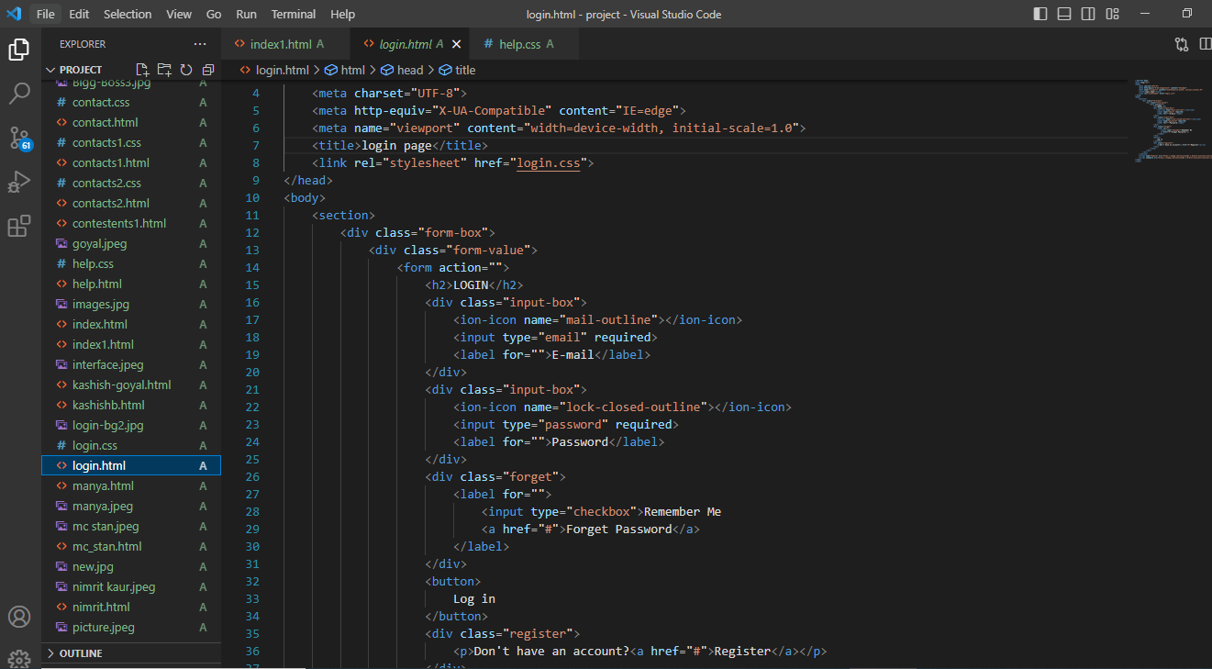

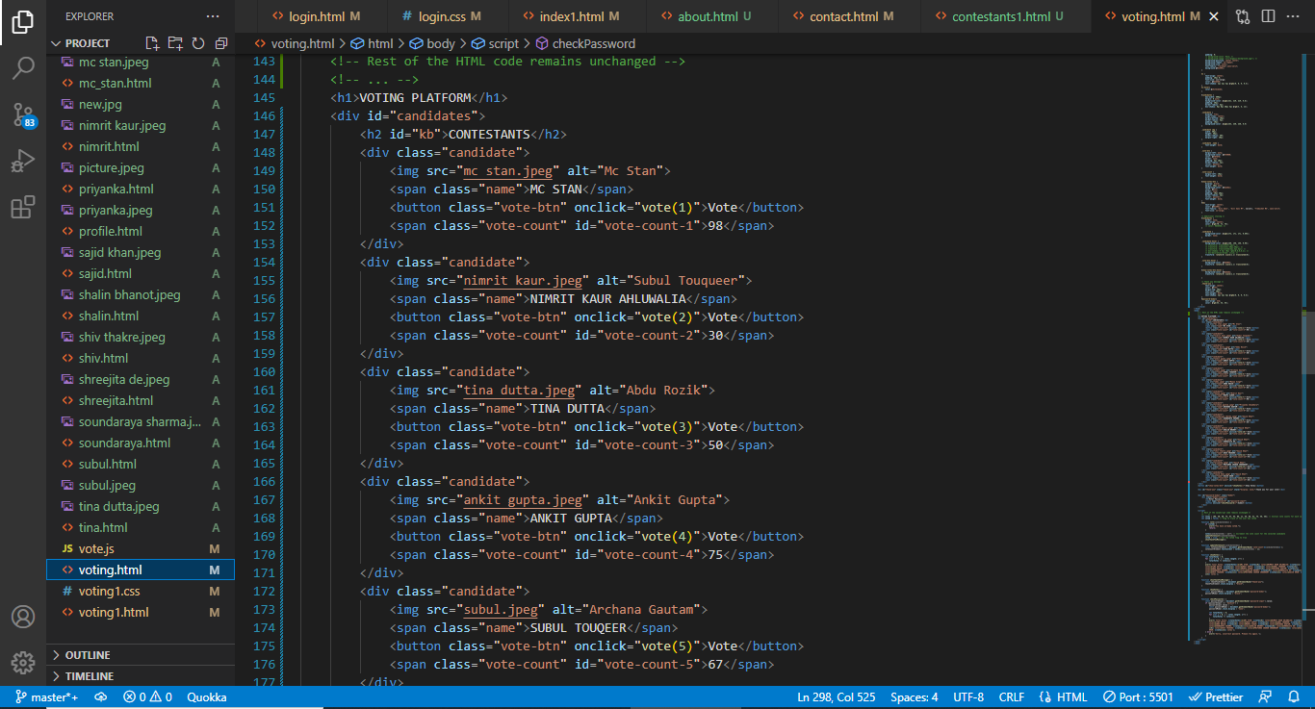

**CSS CODE:**

For styling the webpage we have used CSS. In CSS, firstly we have made universal style and added margin, padding and bot sizing. Then we styled a contain. In container, we’ve have used flex property for aligning the elements in centre, background colour, text colour and adjusted the width and height as per the requirement. In text area, we styled the font by using font size and font family. In output box division we added flex property space between and adjusted the width and height as per our need. In this code, we define the styling for the text area where users will enter their text, and the div element where the word count will be displayed. Overall, CSS is an essential tool in enhancing the appearance and functionality of a word counter and can make it more user-friendly and engaging for your audience.

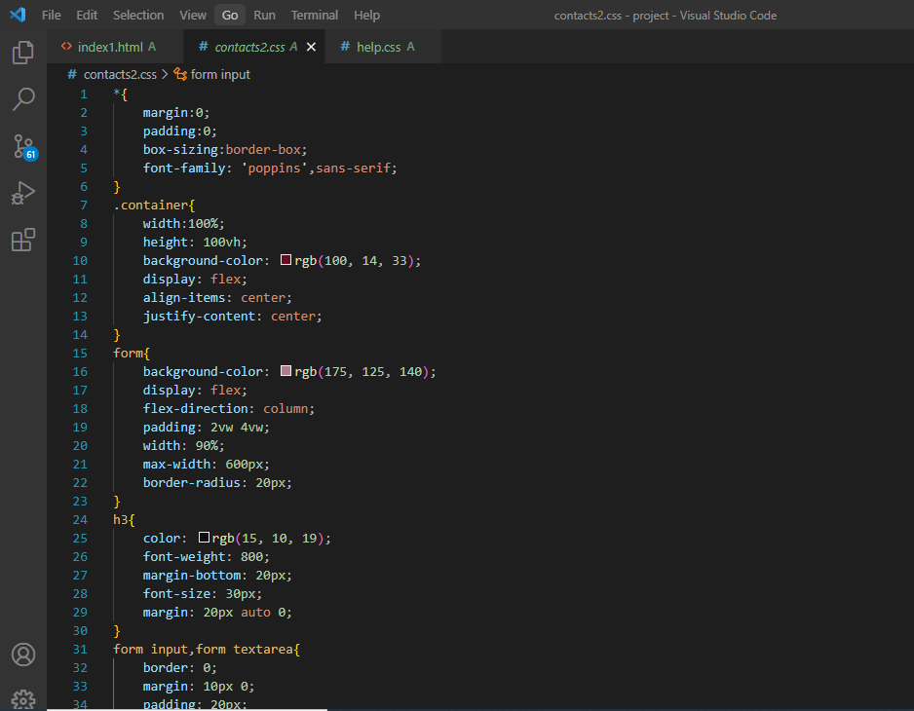

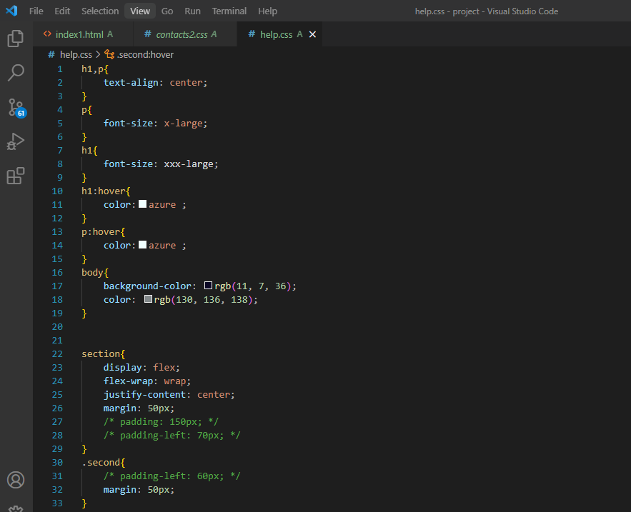

**Here is the output of the codes:**

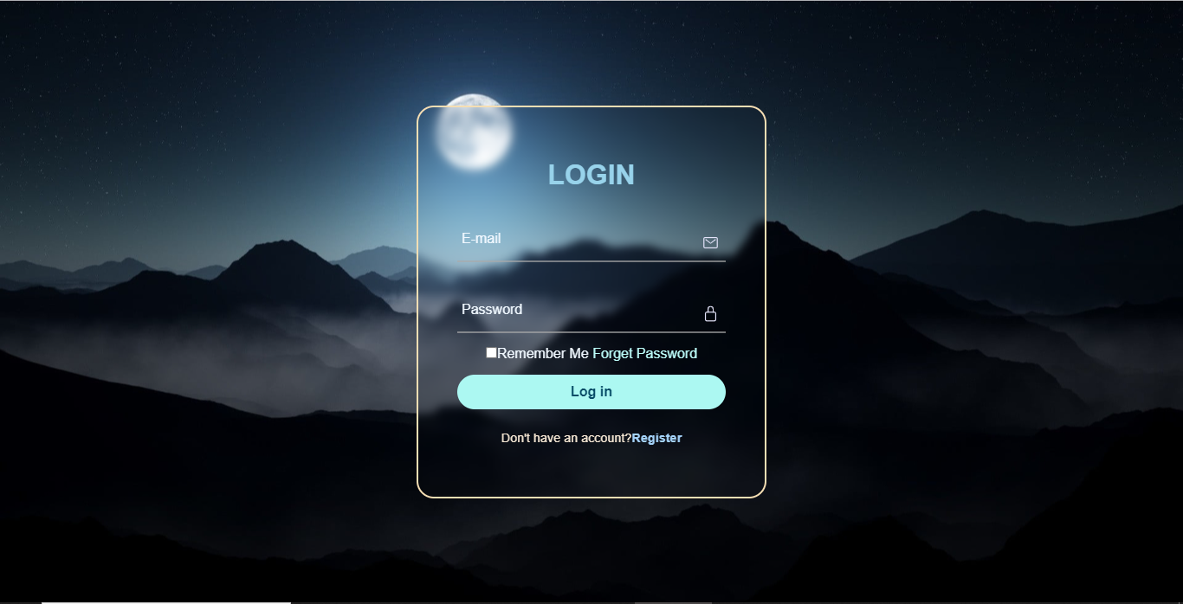

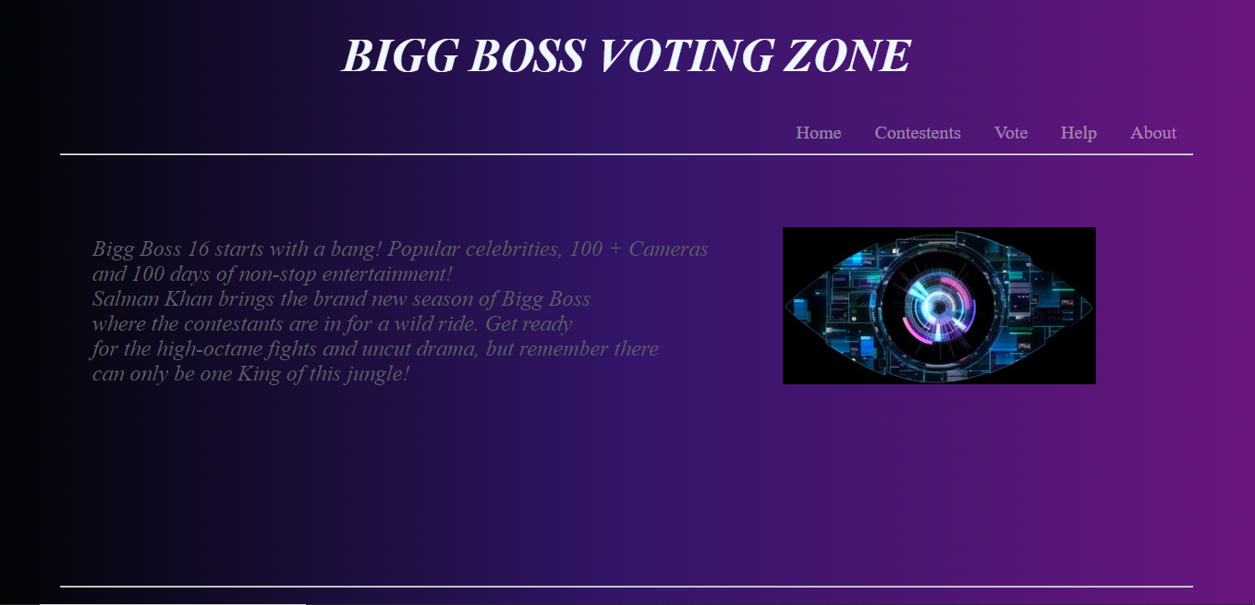

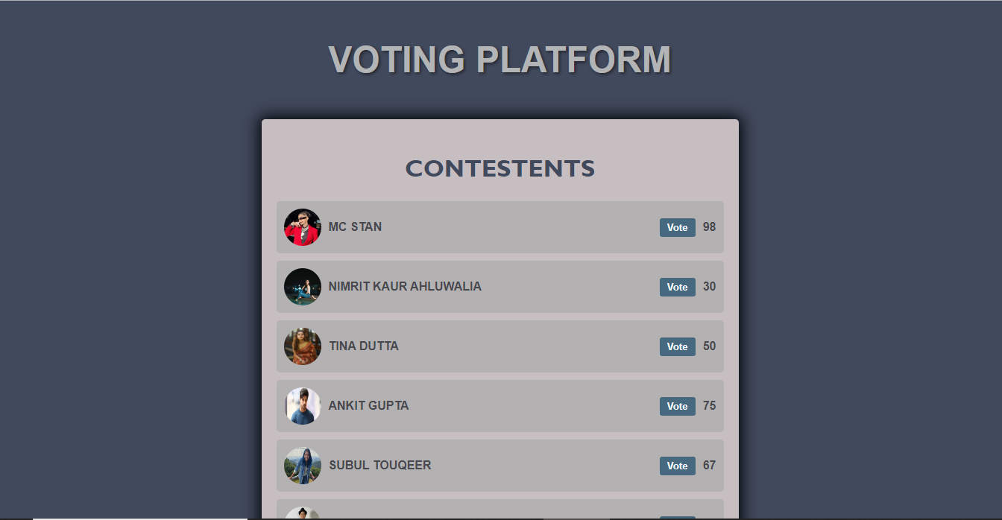

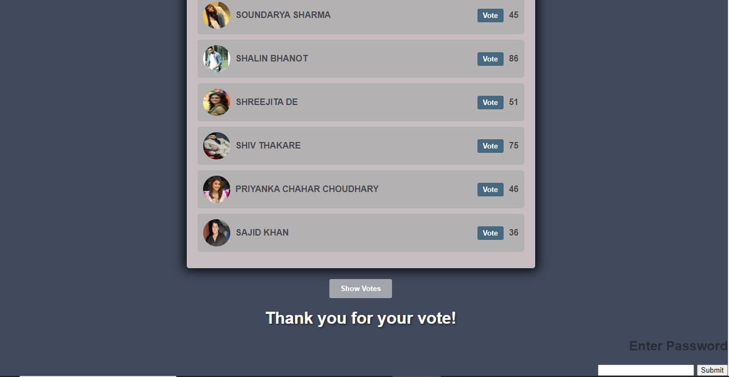

**Bonus Feature:**

1. The login system for vote authentication is designed to ensure secure and fair voting. When users log in, their credentials are authenticated against the stored data to verify their identity. This prevents unauthorized access and helps maintain the integrity of the voting process.

2. To prevent multiple votes from the same user, the system can implement various measures. One approach is to associate each user account with a unique identifier, such as an email address or national identification number. This ensures that each user can only cast one vote.

3. To protect against unauthorized access and data breaches, the login system should implement secure password storage techniques, such as hashing and salting. This ensures that even if the stored data is compromised, passwords remain encrypted and unusable.

4. Furthermore, implementing measures like captcha, rate limiting, and account lockouts after multiple failed login attempts can help prevent brute-force attacks and unauthorized access to user accounts.

5. Regular security updates, monitoring for suspicious activity, and logging user actions are essential to maintain the security and integrity of the vote authentication system.

**Conclusion and Future Scope:**

1. This website is created to effectively track votes with a pleasant user experience and user may found a lot of new features to explore. And in case of any doubt related to anything on our website you may contact our members personally.
2. Adding a voting system for multiple platforms involves creating a system that allows users to cast their votes from various devices and platforms such as desktop computers, laptops, smartphones, and tablets. This requires developing a responsive and mobile-friendly interface to accommodate different screen sizes. Additionally, ensuring cross-browser compatibility and optimizing the voting system for different operating systems is crucial to provide a consistent and seamless voting experience across multiple platforms.
3. Encrypting user data enhances data security by transforming sensitive information into a coded form that can only be decrypted with the appropriate encryption key. This process prevents unauthorized access and ensures that even if data is compromised, it remains unreadable and unusable. Strong encryption algorithms and protocols, such as AES (Advanced Encryption Standard), can be employed to encrypt user data. Implementing encryption measures safeguards user privacy and reinforces the protection of confidential information in the voting system.

**References/Links used:**

* 1. W3schools
  2. Easy tutorials (YouTube channel)
  3. Wikipedia
  4. www.voot.com
  5. MDN references